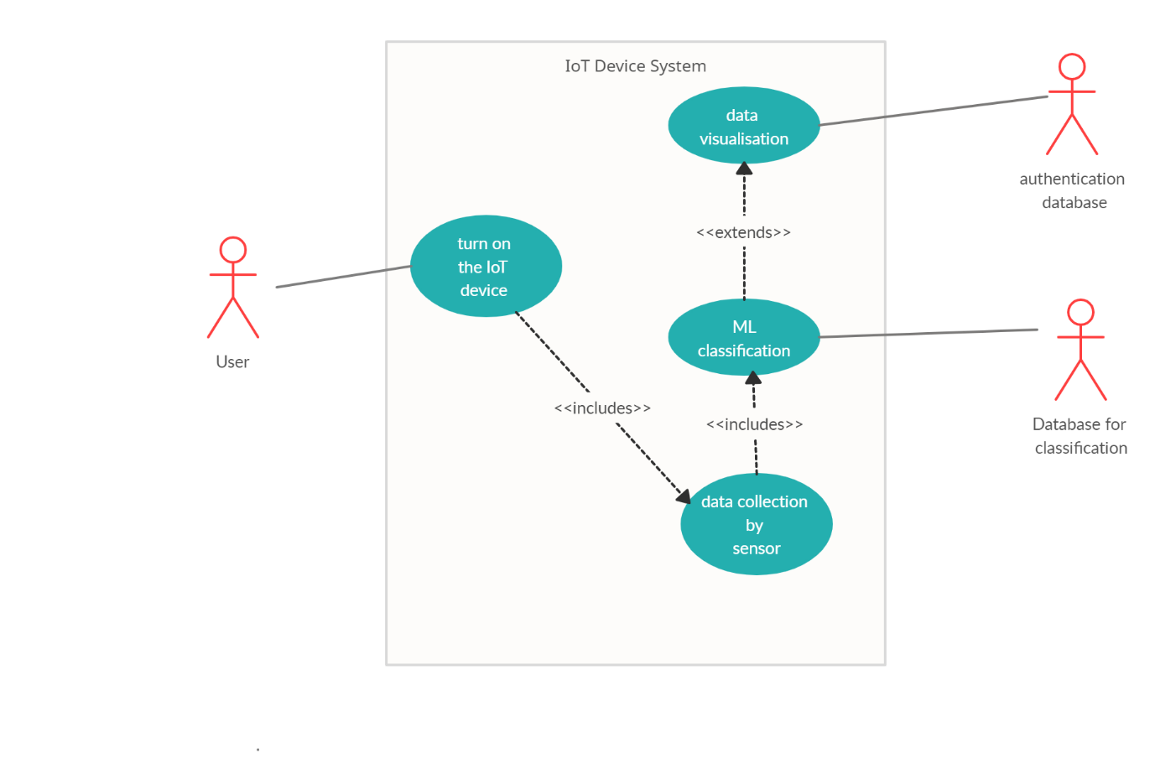

**Use Case Diagram 1**

1. **Setting up the Device**

|  |  |
| --- | --- |
| Precondition | None |
| Use Case | Setting up the Device |
| Actors | User |
| Purpose | Set up the device to check water quality |
| Overview | The user has to place the sensors into the water and turn on the Arduino. |
| Type | Primary |
| Task Sequence | **Successful Scenario:**  1. (AA) User places the sensors into the incoming stream of water.  2. (AA) User turns on the microprocessors.  3. (SR) The microprocessor LED’s begin blinking to indicate that transmission of data is taking place.  **Alternate Scenario:**  2. (AA) User does not require wireless transmission and only sets up one microprocessor |
| Post Condition | 1. User will be able to use the system further. |

**2. Classification**

|  |  |
| --- | --- |
| Precondition | 1. System is in place  2. Data is being collected for analysis by system |
| Use Case | Classification |
| Actors | None |
| Purpose | To classify the incoming water as suitable or unsuitable |
| Overview | The data collected by sensors will be analysed with the help of a Machine Learning model uploaded directly onto the Microcontroller. |
| Type | Primary |
| Task Sequence | **Successful Scenario:**  1. (SA) System transmits sensor data to microcontroller  2. (SR) System uses ML models to analyse data  3.(SR) System classifies water quality as suitable 4. (SR)System turns on pump 1 and pumps the water to fields  **Alternate Scenario:**  3.(SR) System classifies water quality as unsuitable  4.(SR)System turns on pump 2 to send the water to treatment facility |
| Post Condition | Depending on the classification water is either sent to fields or to a treatment facility |

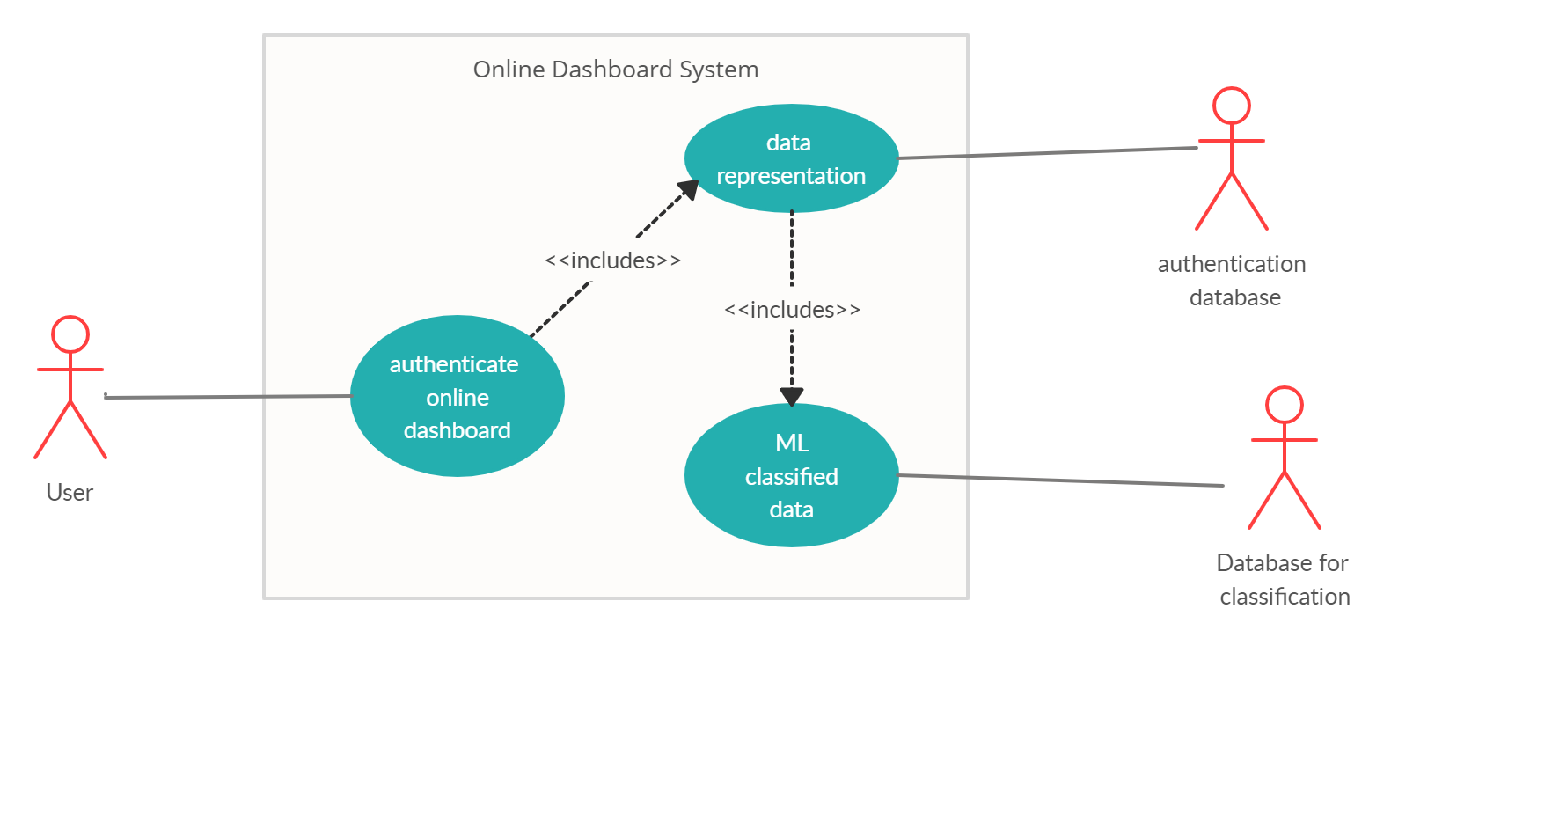

**Use Case Diagram 2**

**3. Setting up online dashboard**

|  |  |
| --- | --- |
| Precondition | 1. Microprocessor must be collecting data |
| Use Case | Setting up online dashboard |
| Actors | User |
| Purpose | The online dashboard will help the user to access past data in order to analyse the long term effects of the system as well as make any improvements onto it |
| Overview | The wifi module will be set up either on one of the microprocessors depending on the user configuration. |
| Type | Primary |
| Task Sequence | **Successful Scenario:**  1. (SA) System LED are blinking to indicate transmission of data  2. (AA) User connects Wi-Fi module with the internet by providing the Name and password.  3. (SR) System blinks the Wi-Fi LED to indicate connection with the internet and dashboard  **Alternate Scenario:**  2.(AA) The user refuses to connect the Wi-Fi module with the internet  3.(SR)The system does not connect to the dashboard to internet and the Wi-Fi LED does not blink |
| Post Condition | 1. Data will be transmitted to the online dashboard |

1. **Display**

|  |  |
| --- | --- |
| Precondition | 1.Sensor data has been analysed and water quality has been classified |
| Use Case | Display |
| Actors | None |
| Purpose | To display analysed data about water quality through graphs on an online dashboard for the user to see |
| Overview | After the sensor data is collected and analysed the system displays the data in graphical form on an online dashboard which a user can access after authentication |
| Type | Primary |
| Task Sequence | **Succesful Scenario:**  1. (AA)The user logs in to the online dashboard after authentication  2. (SA) System displays the analysed data on the online dashboard  3.(AA) User views the data and can analyse and make decisions based on the data  **Alternate Scenario:**  1. The user forgets the password and has to reset it  3.(AA) User wishes to end the session and can log out |
| Post Condition | 1. Sensor data about the water is displayed |

**Typical Course of Events/Successful Scenario/Normal Scenario**

1. (AA) The user starts the IoT device
2. (SR) The field component will collect the temperature, pH value, turbidity, SAR value and flow of water
3. (SR) The LORA module transmits the data to microcontroller receiver
4. (SR) The ML models analyse the data and determine whether water is fit for irrigation or not
5. (SR)The microcontroller diverts the flow of water based on the result obtained
6. (SR) The system uploads data online on a dashboard
7. (AA) The user creates an account on the online dashboard and logs in
8. (AA) The user accesses the data for his own use

**Alternative Flow Of Events**

1. The user has change of mind and does not turn on the device
2. The user opts out of creating an account on the online dashboard

**Exceptional Flow Of Events**

1. The field sensor is not properly placed due to which it is unable to function properly giving a wrong reading
2. The user enters the incorrect password causing an error
3. The user is unable to access the data due to session expiration